**Cloud answer**

Step 0: Go to IAM

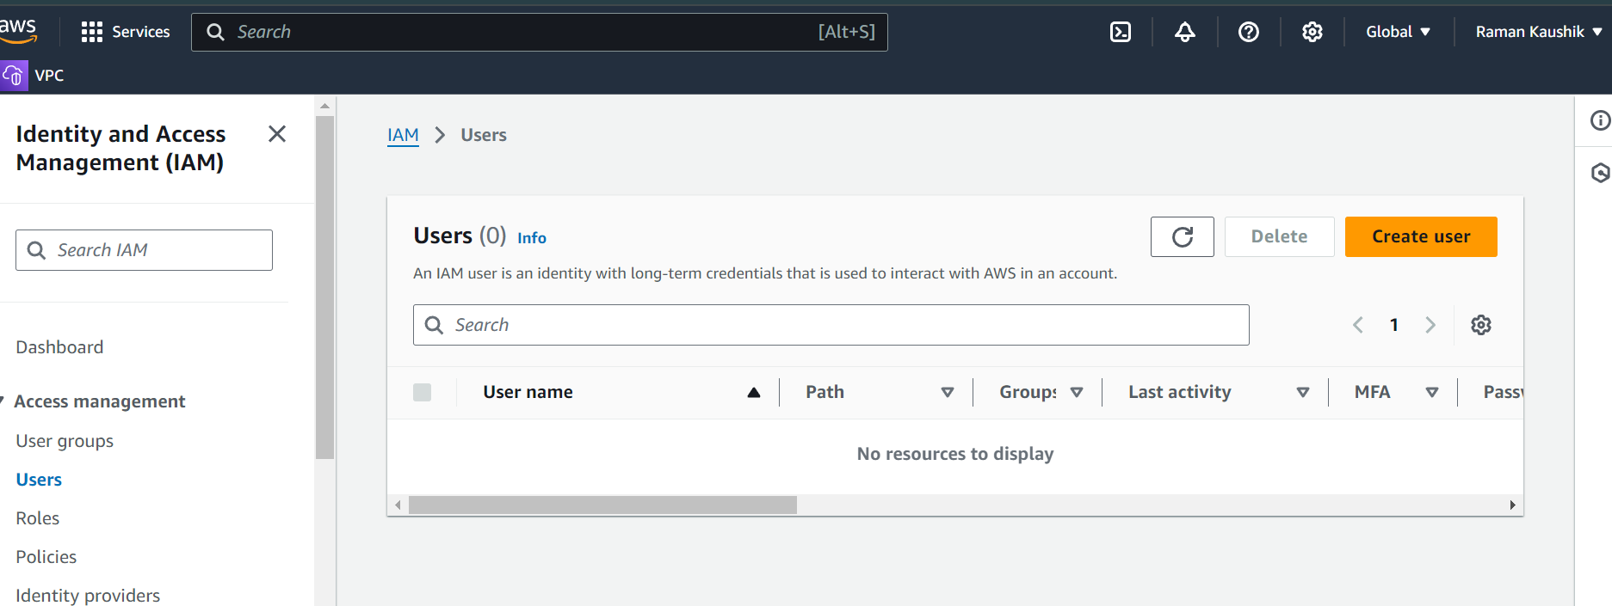

Step 1: Create user with name Raman

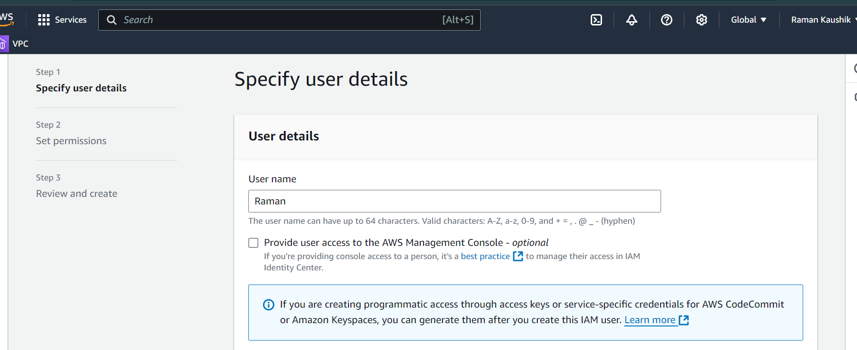

Step 2 : Give permissions to user to EC2 Full access

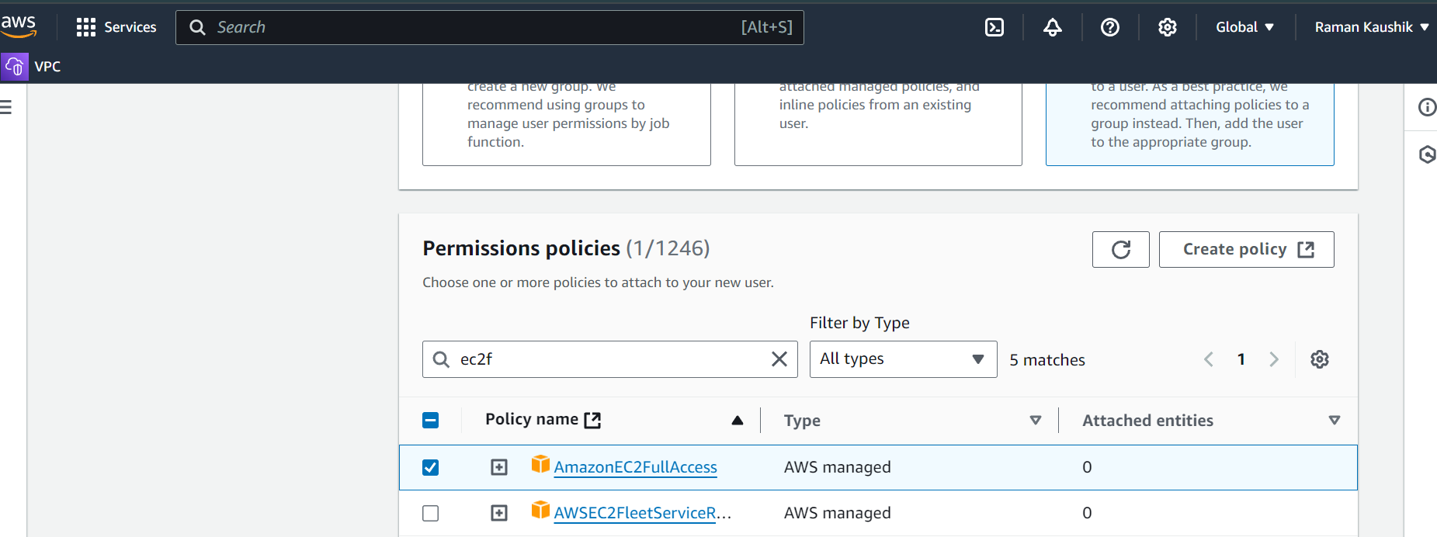

Step 3 :

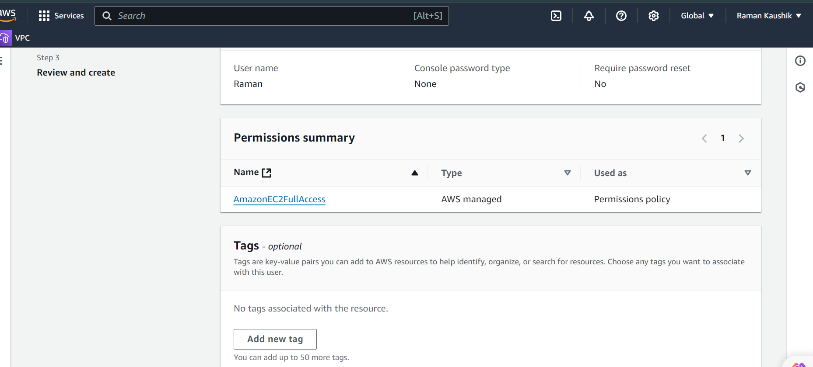

Step 4 : user created successfully

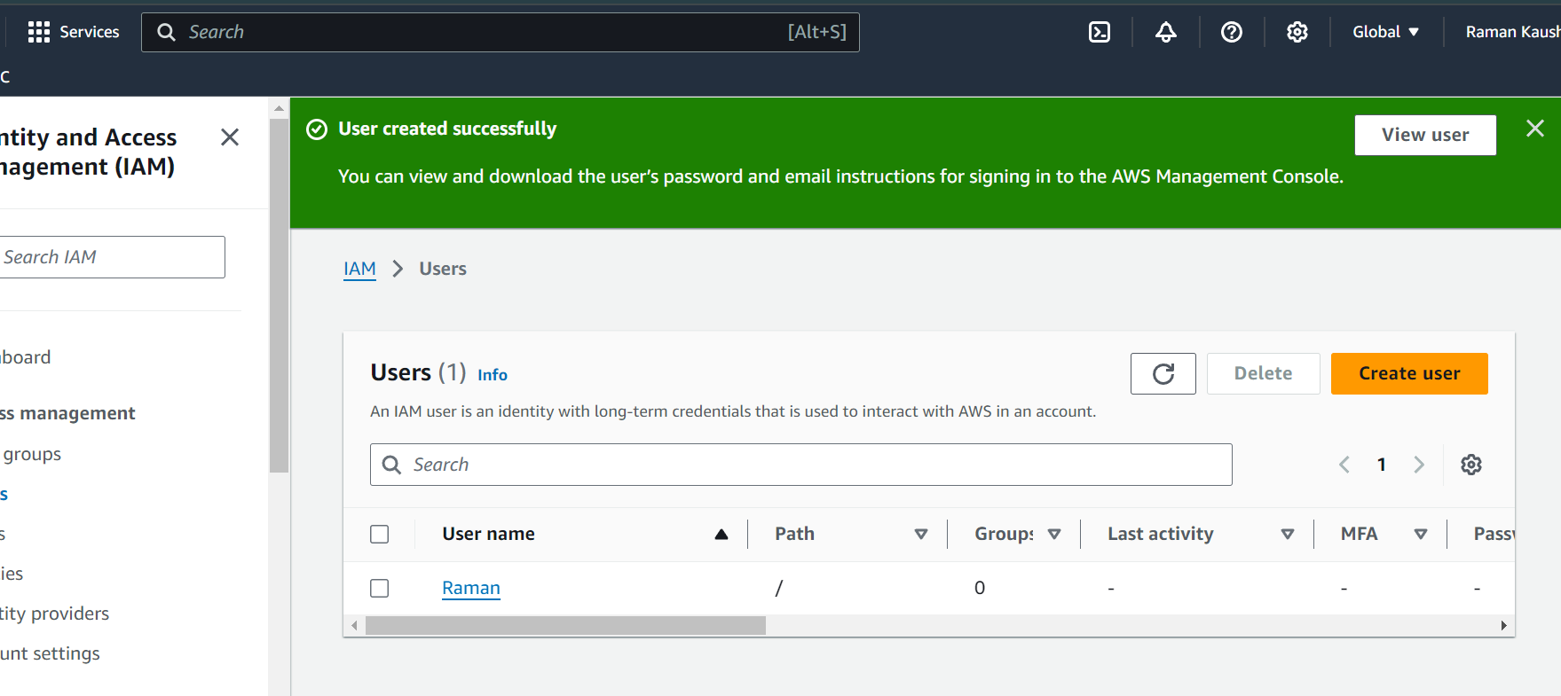

Step 5 : Create console sign and password

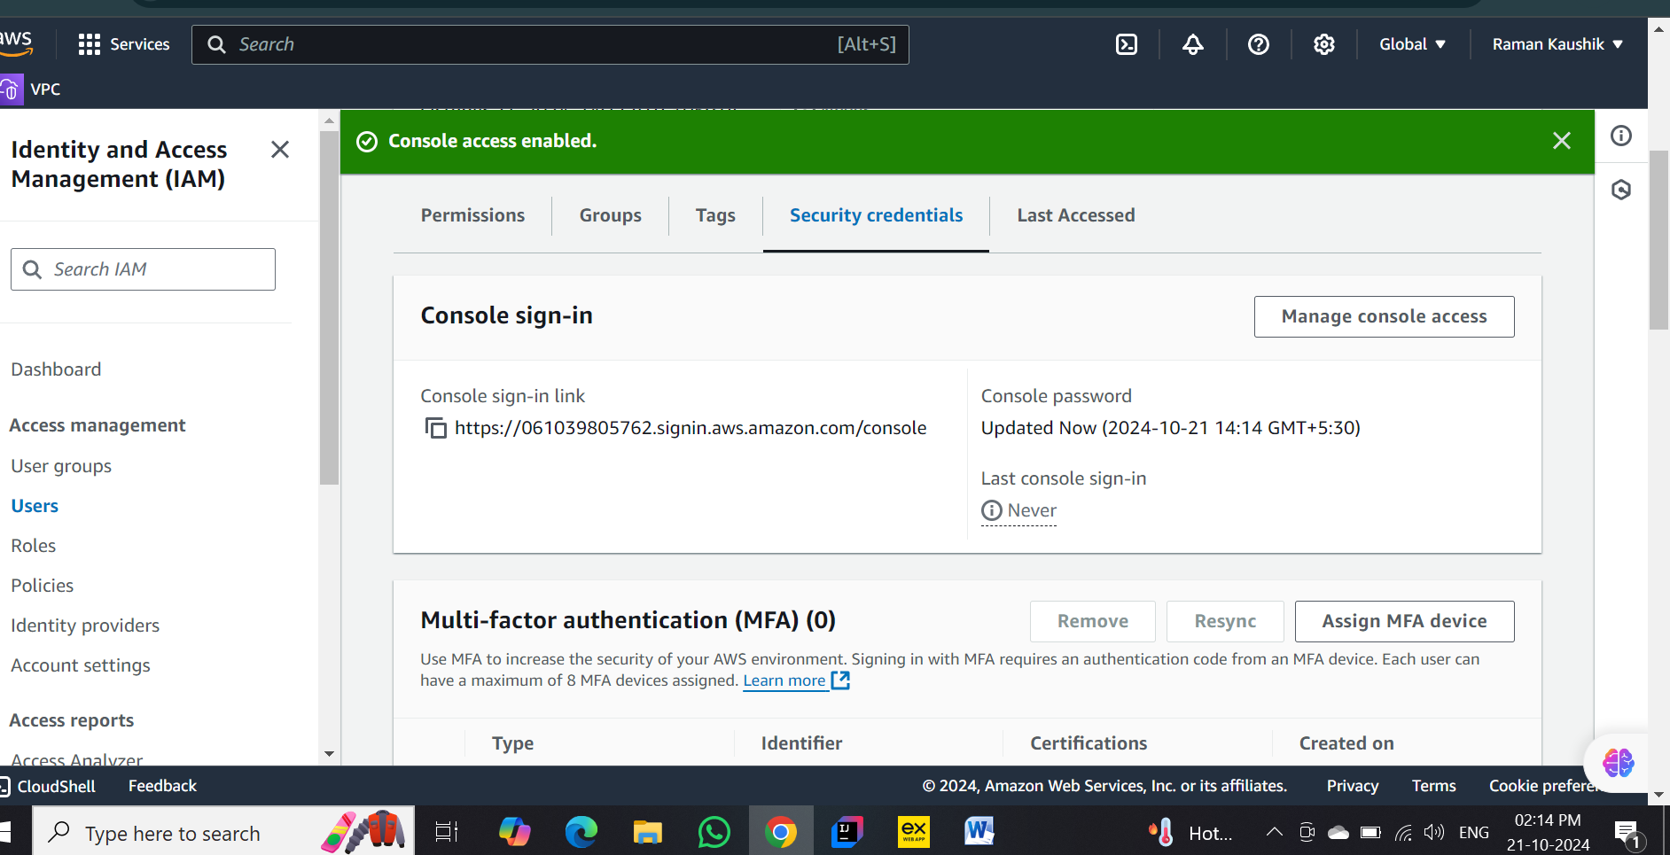

Step 6: Id and password created successfully

Console signin link : https://061039805762.signin.aws.amazon.com/console

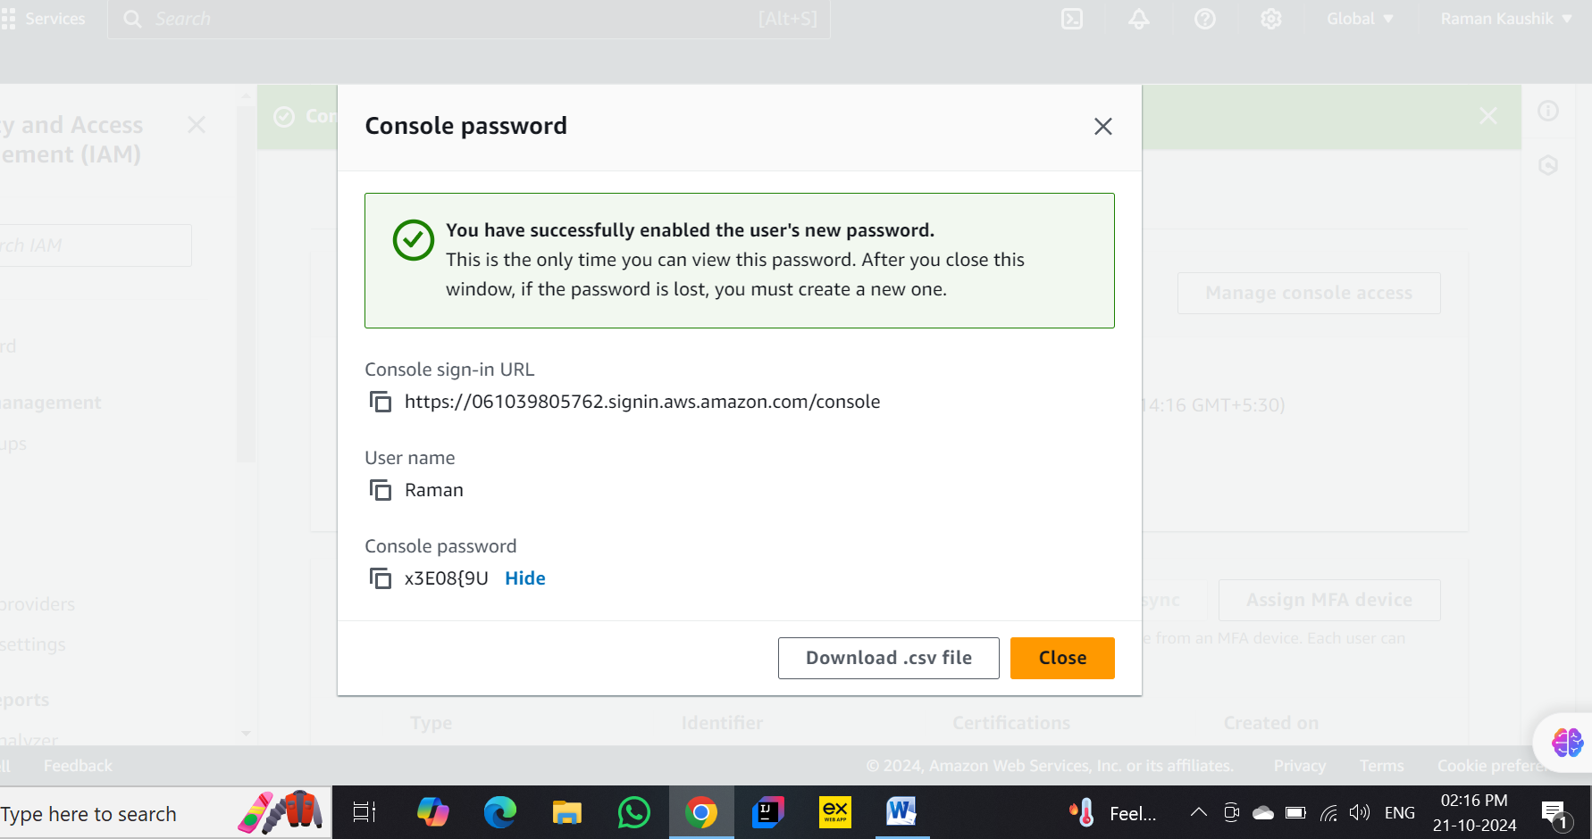

Step 7 : Logged in as new iam user

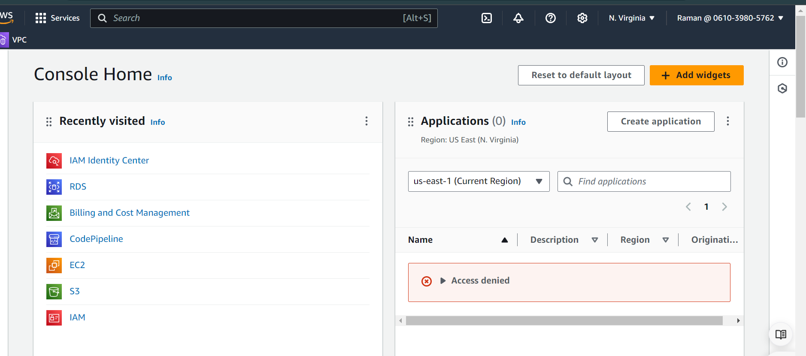

Step 8 : Creating instance in iam user for check its working or not

User name is IAM-Raman

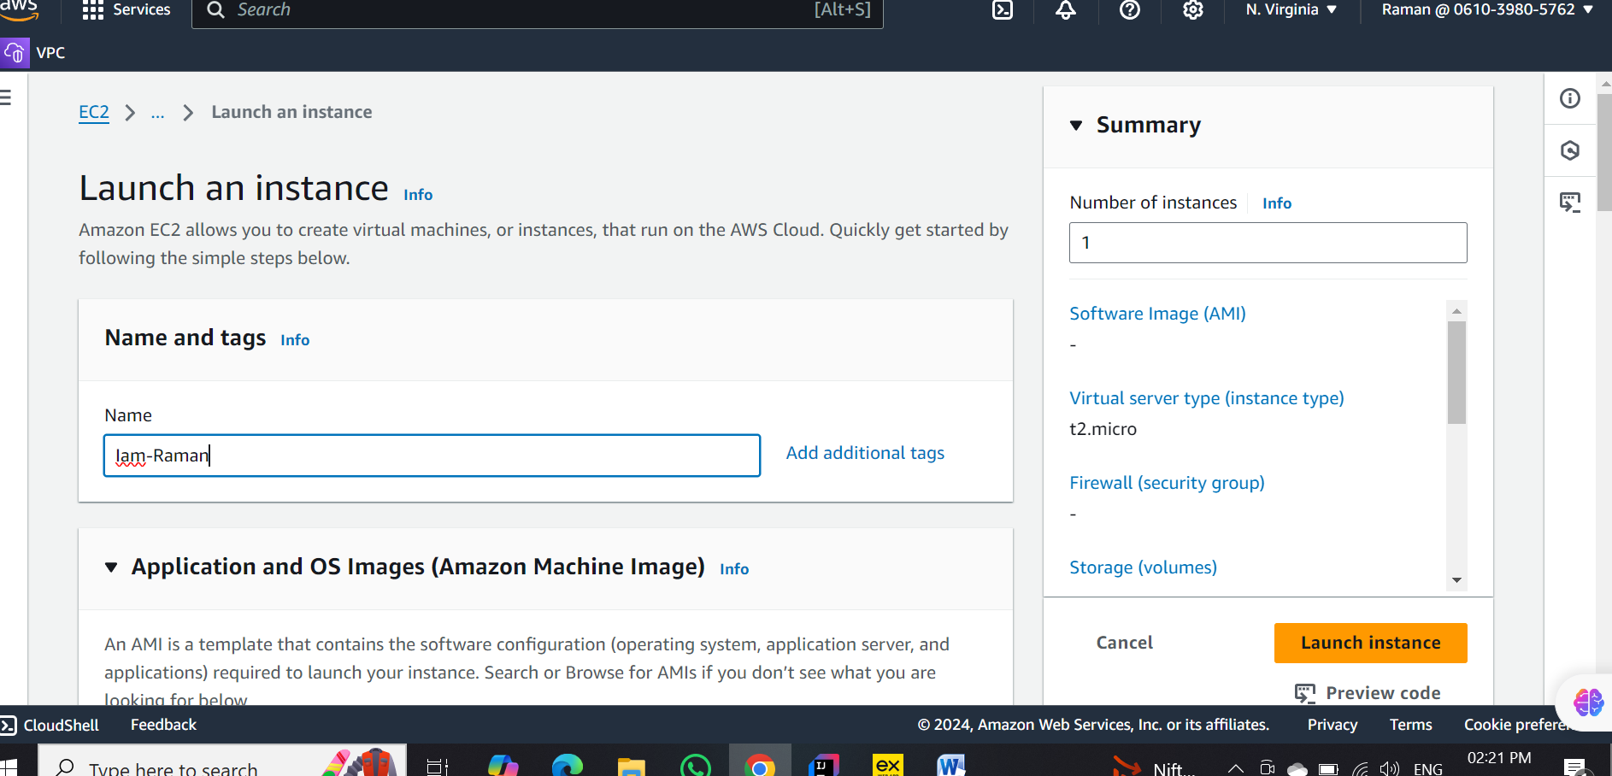

Step 9 : Choose os for ec2

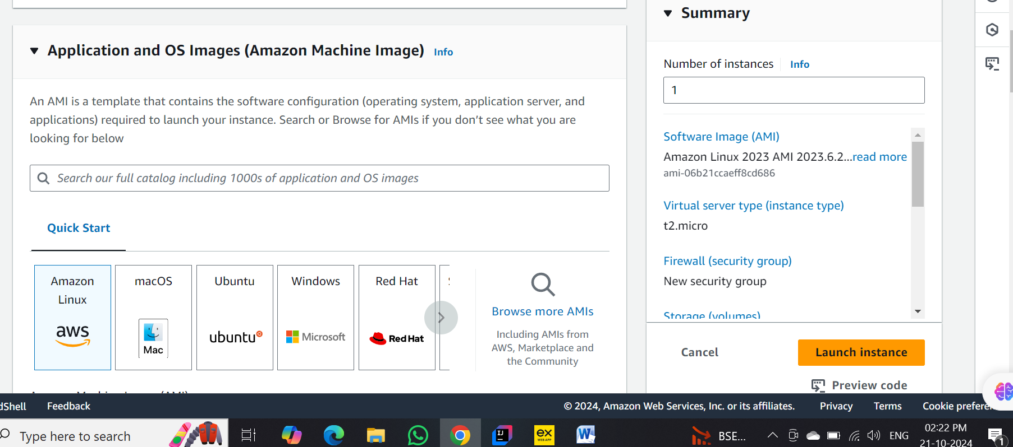

Step 10 : Chosse instance type

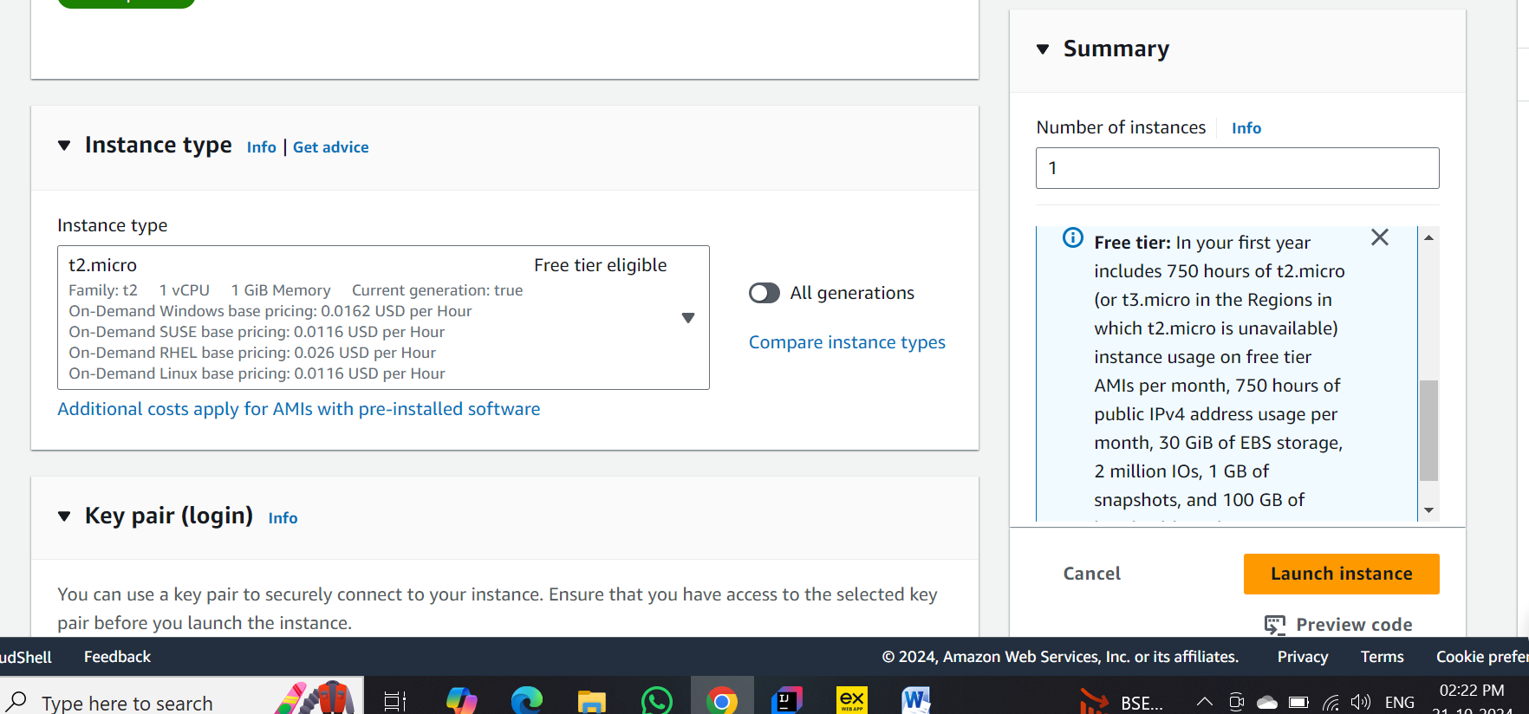

Step 11: Create key pair

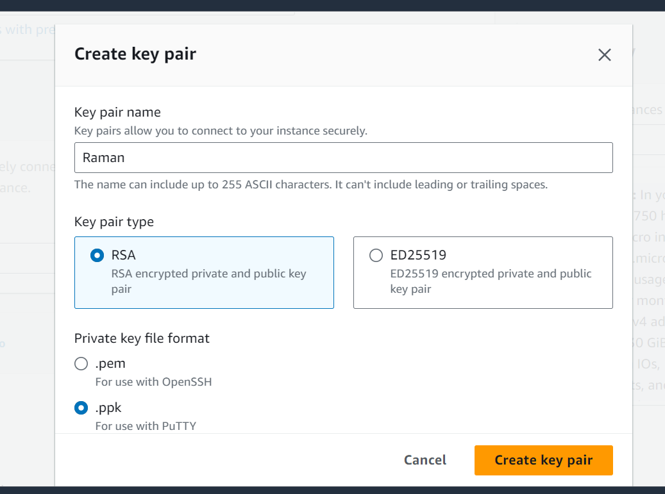

Step 12 : Create security group

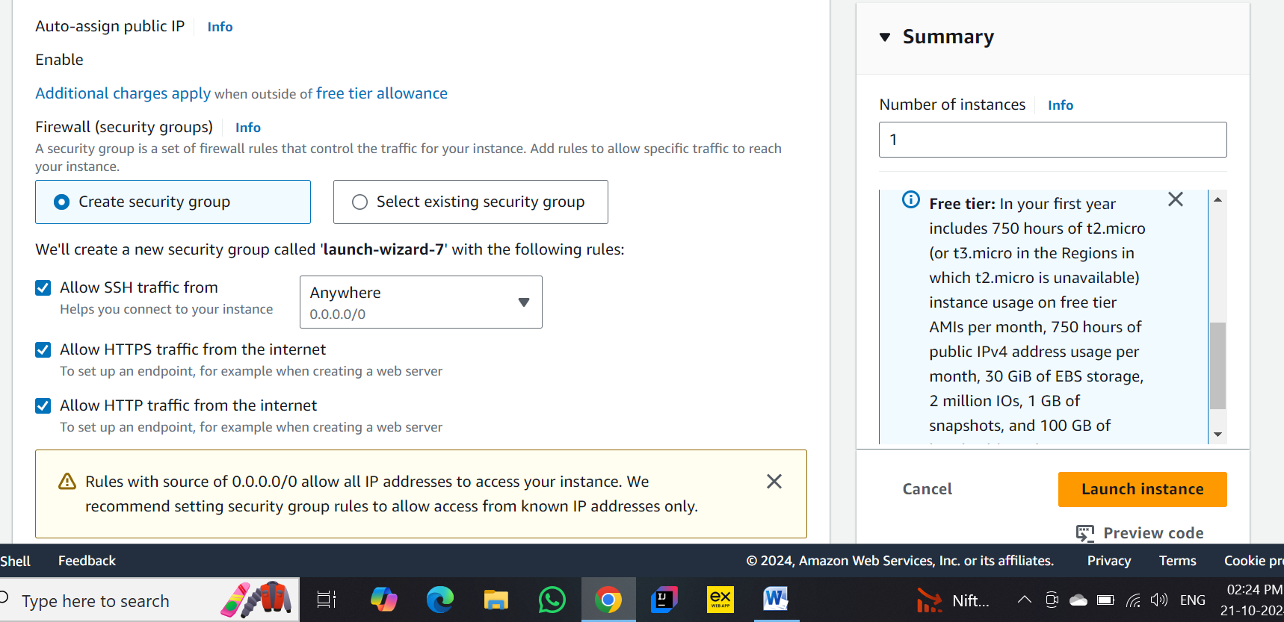

Step 13 : launch instance

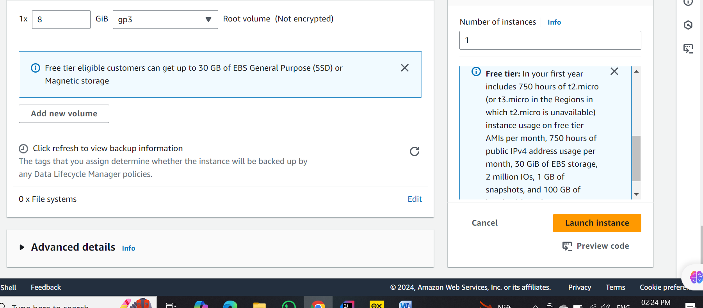

Step 14 : Instance launched successfully

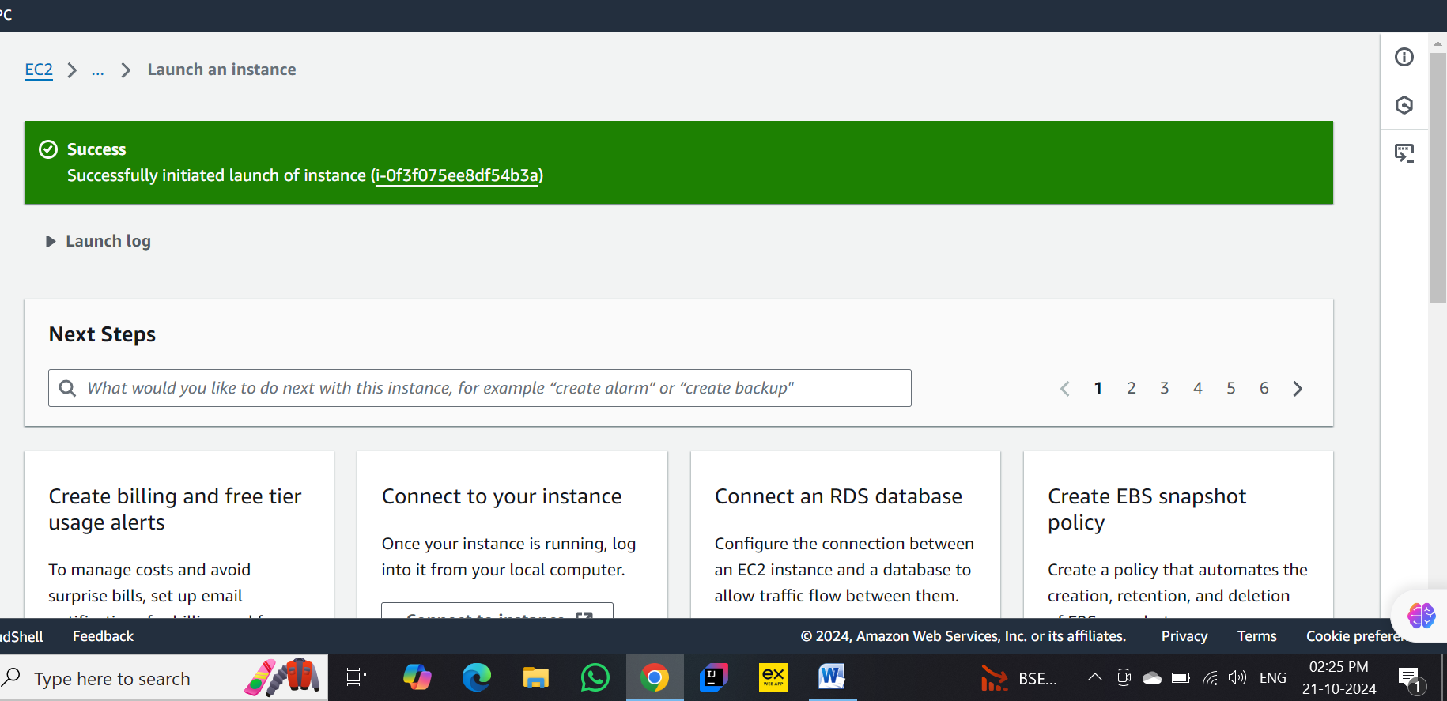

Step 15 : Instance running

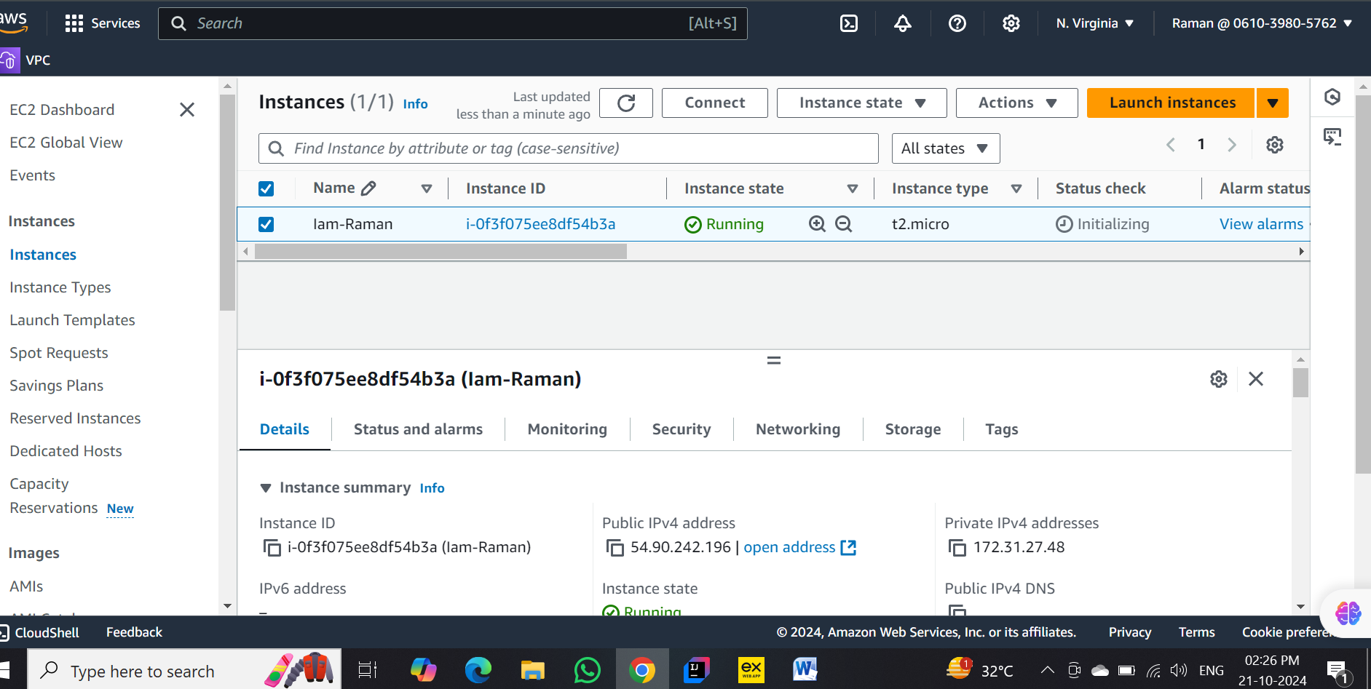

Step 16 : Now terminateing(Stopping) instance

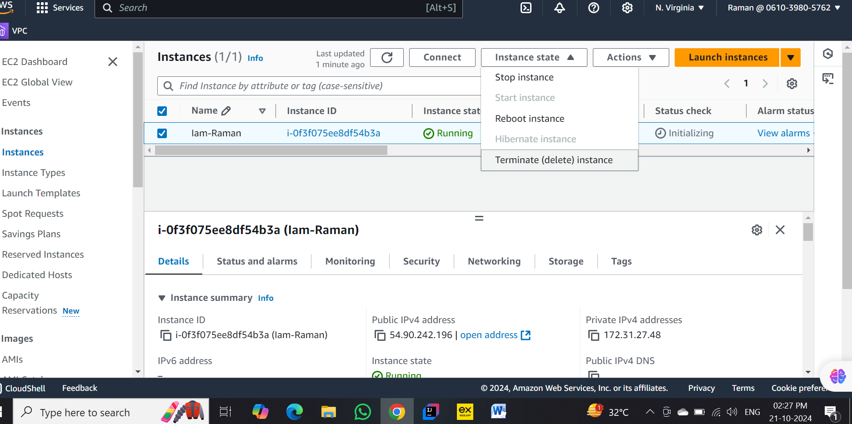

Step 17: Instance Stopped

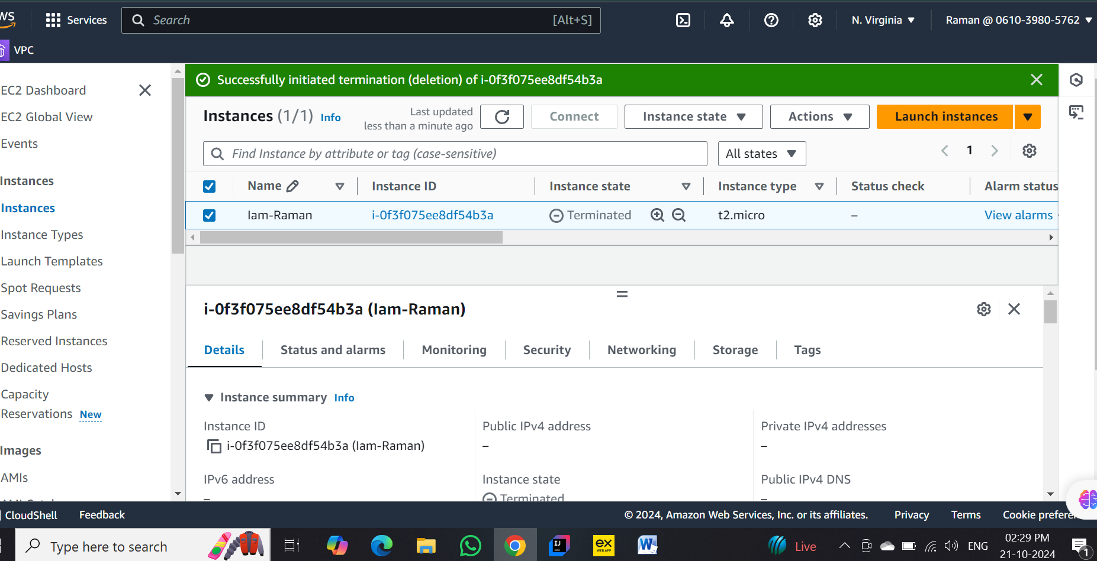

Step 18 : Go to root user

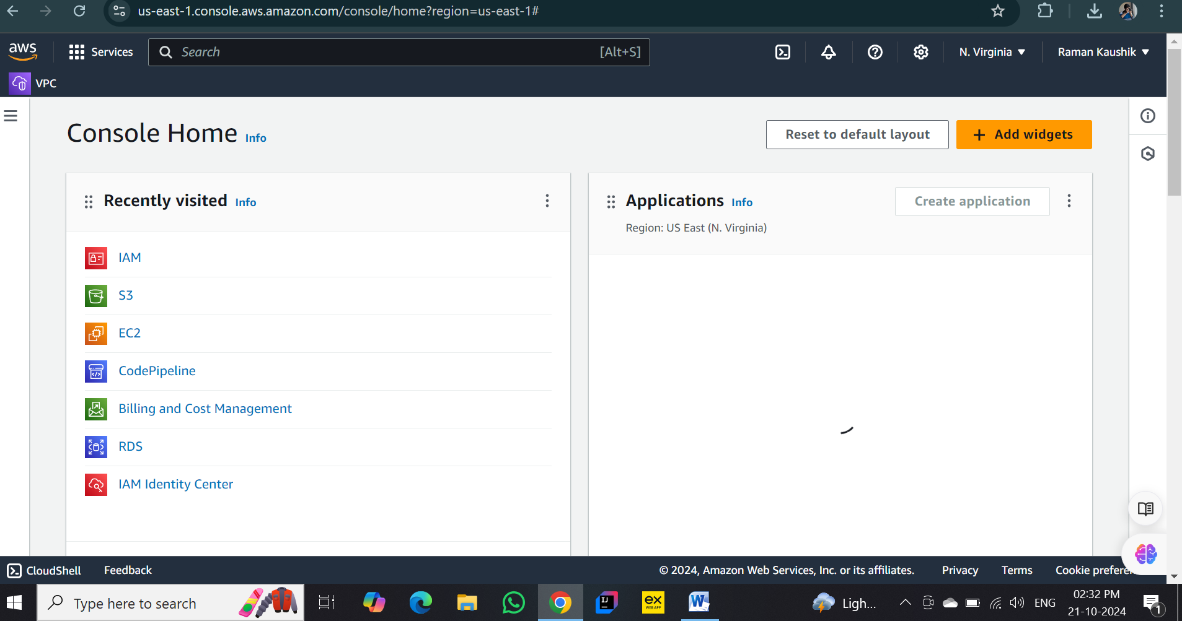

Step 19 : Createing S3 Bucket in root user with name “raman-bucket-exam”

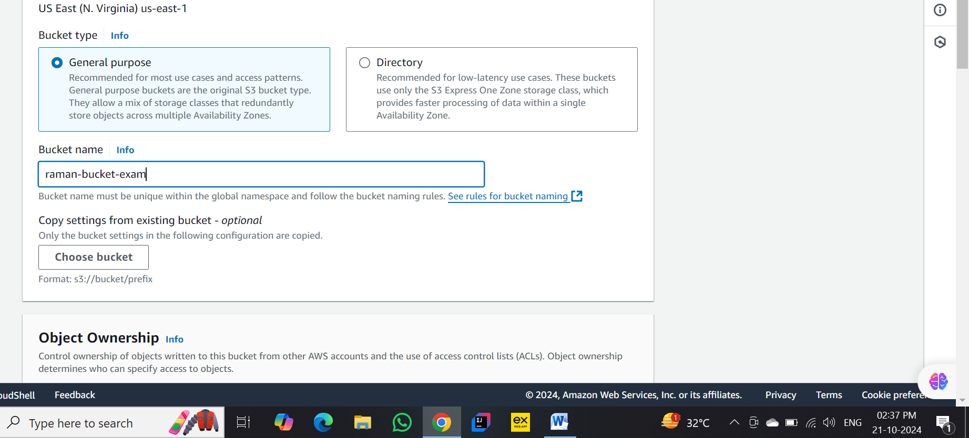

Step 20 : Enabling ACLs

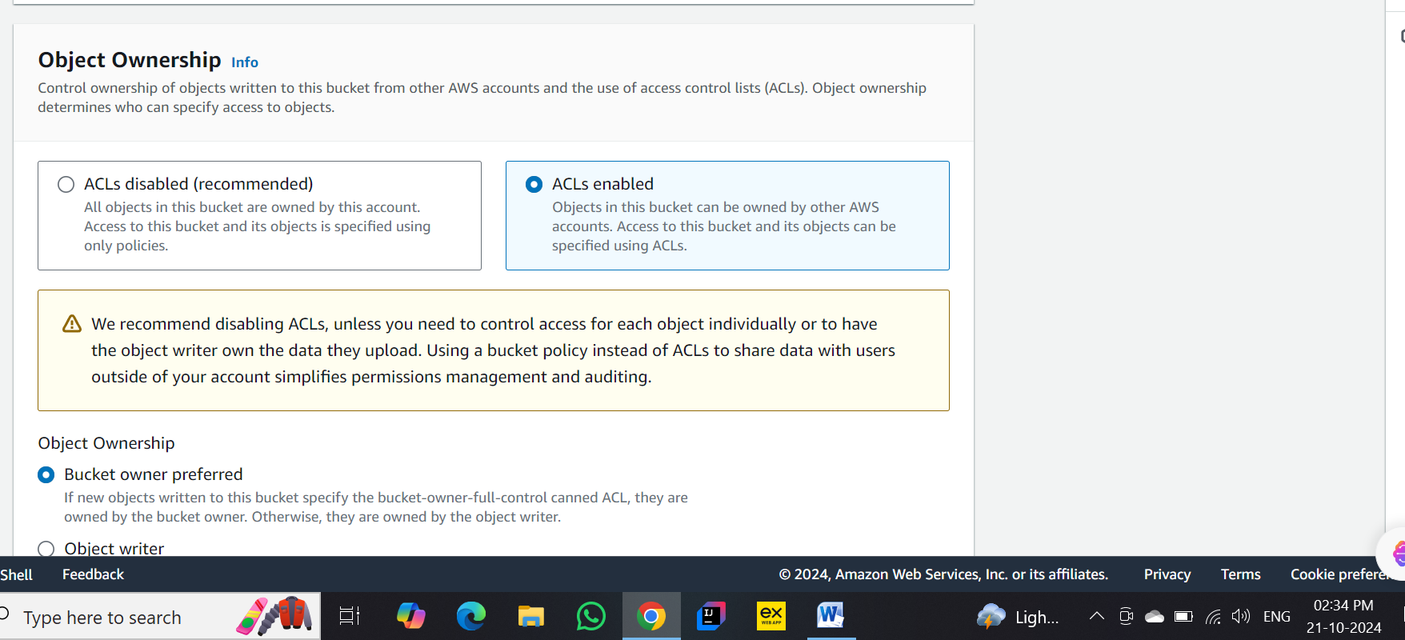

Step 21: Allowing all public access



Step 22 : Check box

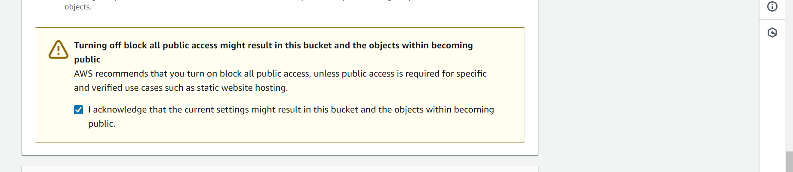

Step 23 : Enabling bucket versioning

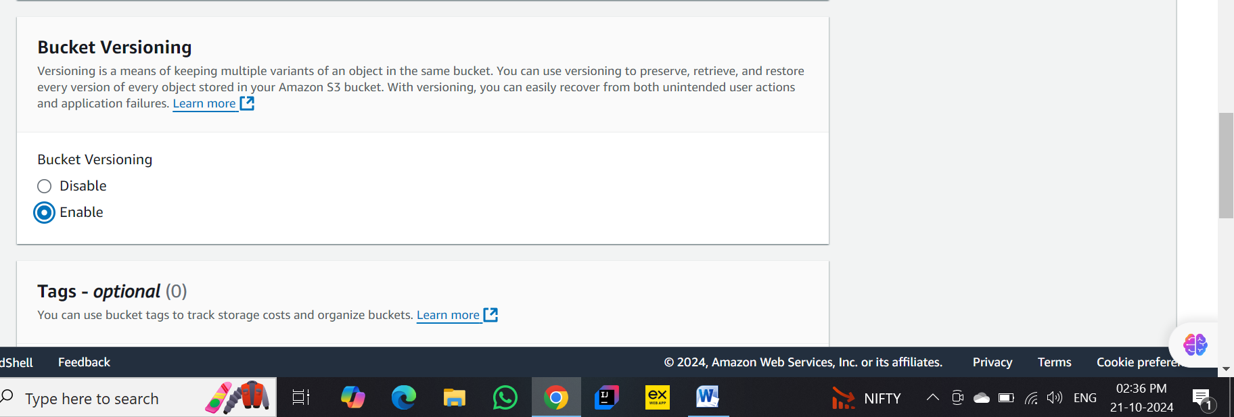

Step 24 : Bucket created

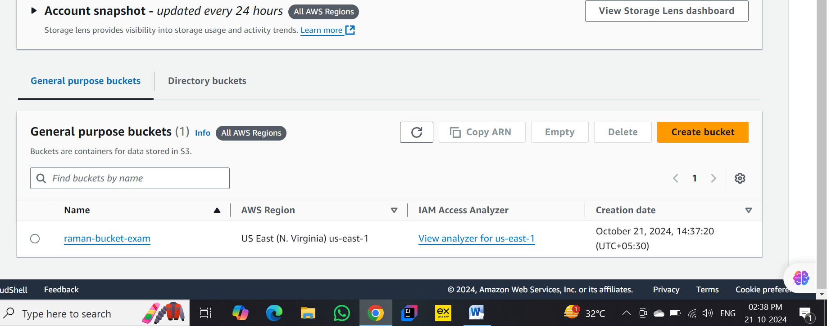

Step 25 : entering in bucket

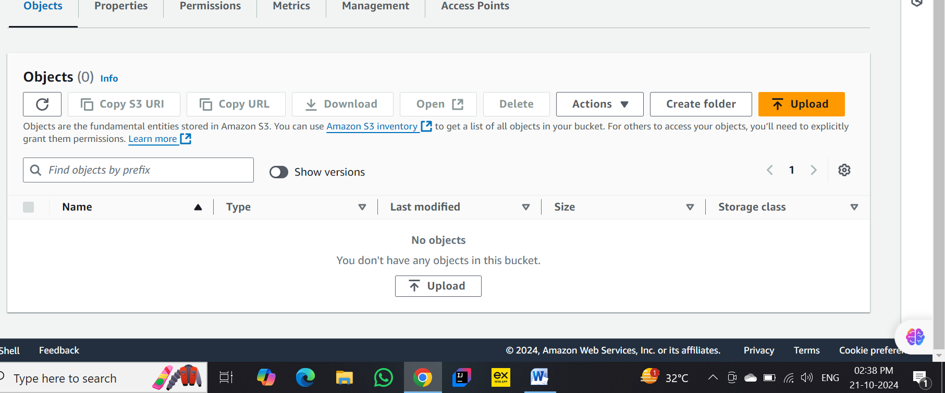

Step 26 : Upload an html file

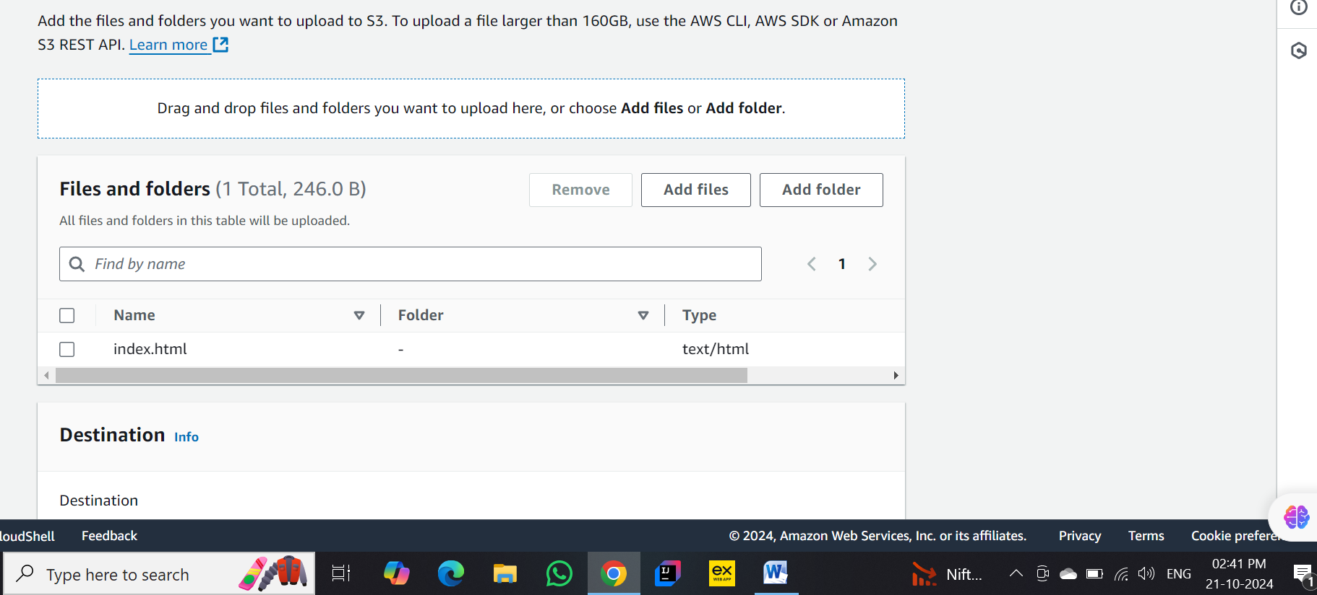

Step 27 : html file uploaded successfully

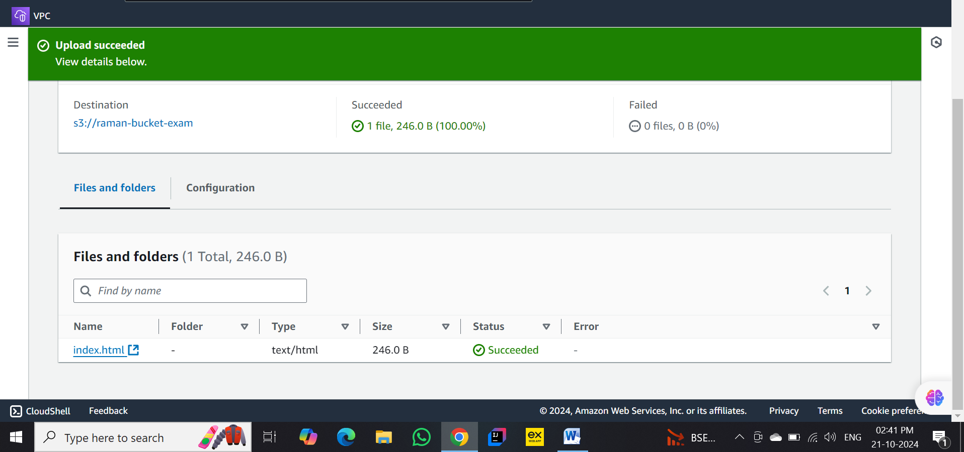

Step 28 : Go into html file

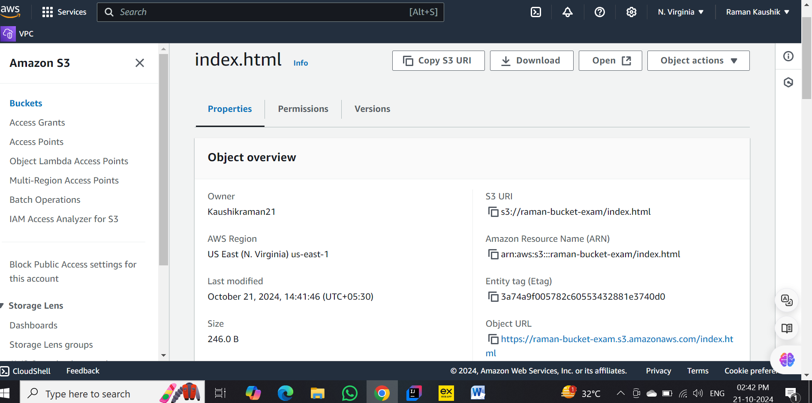

Step 29 : Click on object url for check is it working or not

url : <https://raman-bucket-exam.s3.amazonaws.com/index.html>

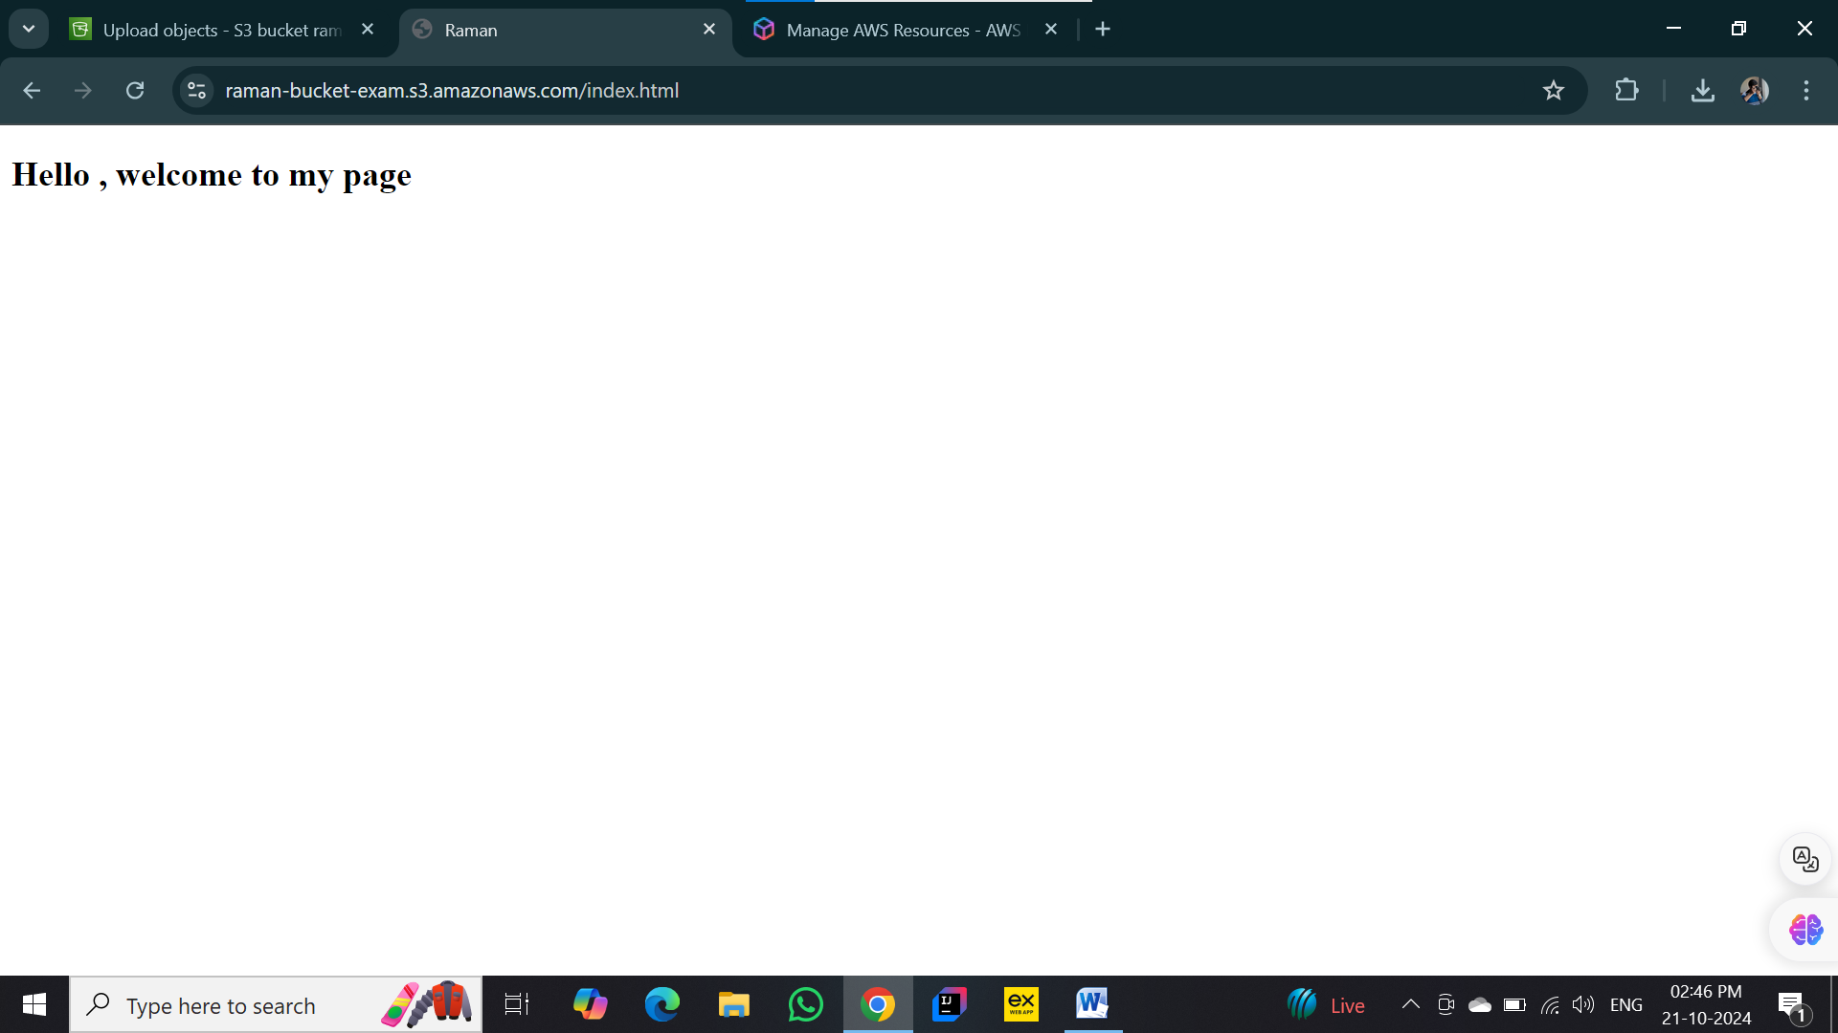

Step 30 : go to permissions for publicly accessible

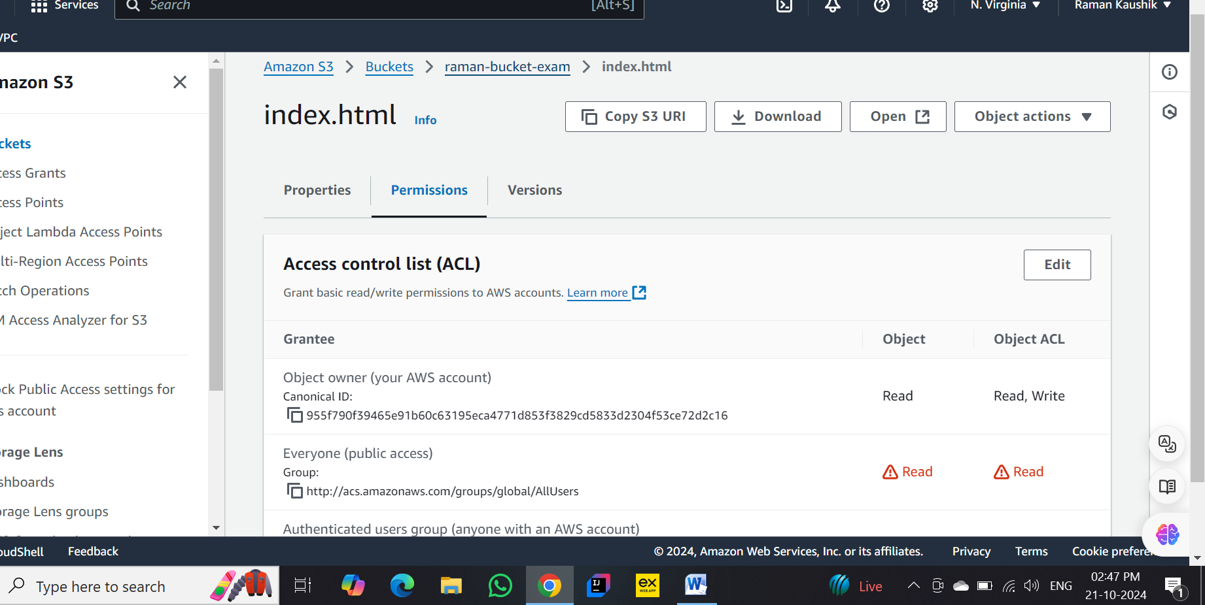

Step 31 : check in everyone public access and also check authenticated users group

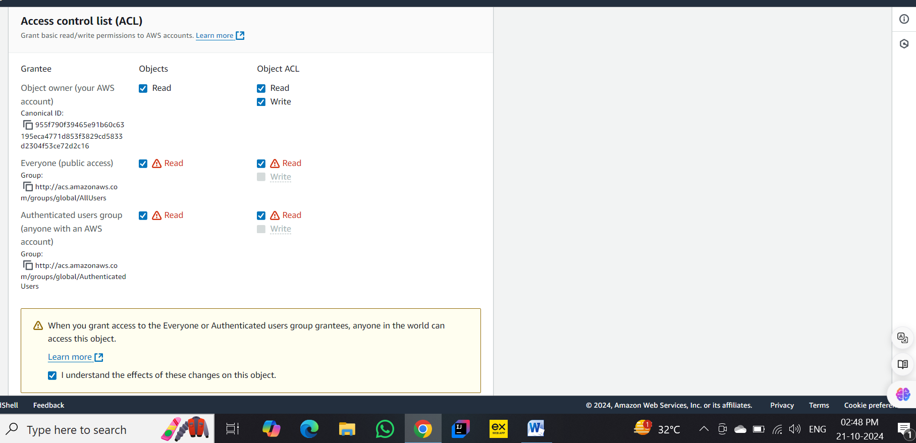

Step 32 : Save changes

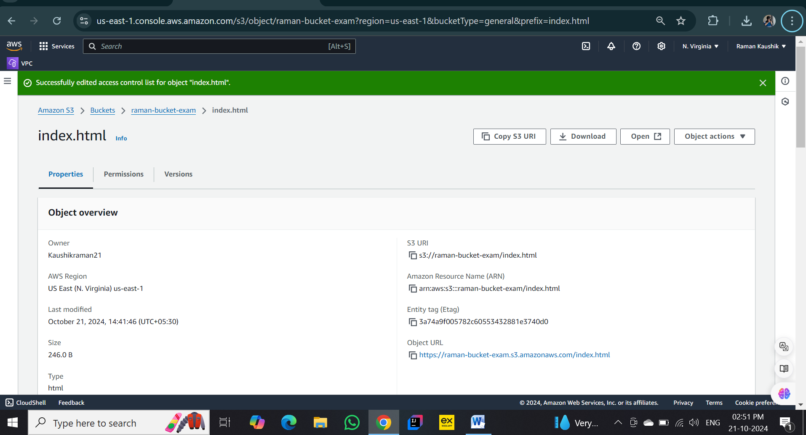

Step 33 : click on object url and it shows our html page

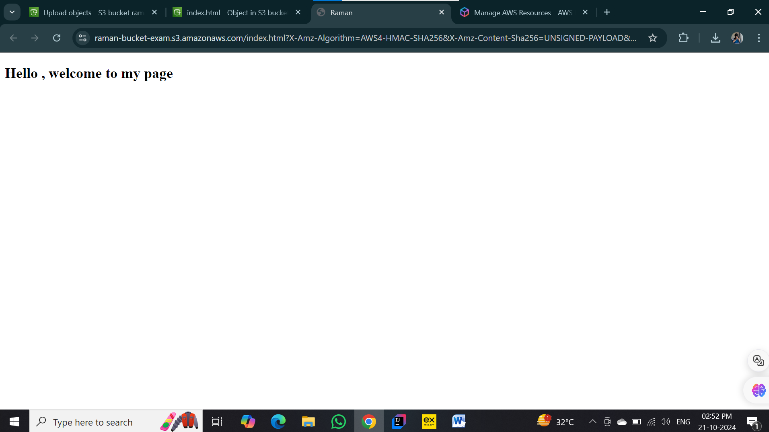

Step 34 : url - <https://raman-bucket-exam.s3.amazonaws.com/index.html>

Linux Answer

Answer 1 :

#!/bin/bash

echo "Enter three numbers: "

read num1 num2 num3

if [ $num1 -le $num2 ] && [ $num1 -le $num3 ]; then

smallest=$num1

elif [ $num2 -le $num1 ] && [ $num2 -le $num3 ]; then

smallest=$num2

else

smallest=$num3

fi

avg=$(echo "scale=2; ($num1 + $num2 + $num3) / 3" | bc)

sum_of_sqr=$(echo "$num1^2 + $num2^2 + $num3^2" | bc)

echo "Smallest number: $smallest"

echo "Average of the three numbers: $avg"

echo "Sum of squares of the three numbers: $sum_of_sqr"

Output:

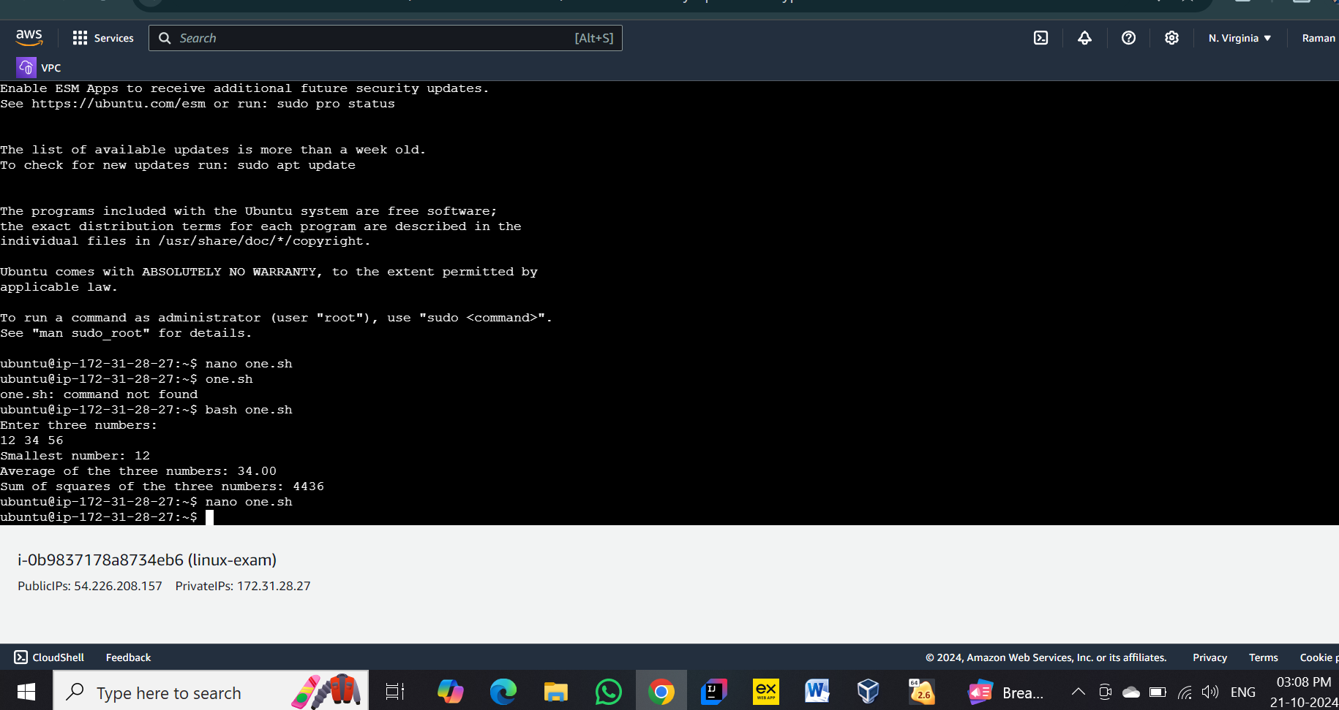

Answer 2 :

1. mkdir raman
2. mv raman raman_new
3. rmdir raman_new